

**MPSTME, NMIMS Shirpur**

**Department of Computer Engineering**

**B.tech 2nd Year**

**Subject: DBMS**

|  |  |  |  |
| --- | --- | --- | --- |
| S. NO. | NAME | ROLL NUM | SAP ID |
| 1 | Deyan Shah | E276 | 70552100126 |

**Jio Saavn DATABASE MANAGEMENT SYSTEM**

SUBMITTED TO : Sachin Bhandari

***AIM:***

***DESCRIPTION:***

We Prepared a database managenment system based on the working of jio saavn . prepared an ER diagram schema cardinalities

Users and artists are the primary entities that JIO Saavn is composed of. Unique userID & artistID’s will be given to each of them as primary key attributes to ensure every account can be uniquely identified. Users will also be able to add other users as friends and see their live listening activity on their dashboard. Friends will be considered a weak entity within this database.

A user needs a Jio Saavn account to use the service. To create an account, the user needs to provide the following information: email, phone number, name, date of birth, and gender. If a user wishes to become a subscriber, they will need to purchase a monthly subscription. In this scenario, a subscription plan (family, duo, student, individual) and payment information is required. For artists, a collection of their published music will be found on their profile. It will include song data such as titles, artist (and features), length, # of streams, and albums.

A search for music should be categorized into the genre, region, language, artist and length of the search results. Results will also display album covers, which have no effect on the categorization. A user can also create playlists and edit the name and description of these playlists. The number of songs in the playlist will be recorded and displayed. An automatic playlist can be created based on the user’s liked songs and followed artists in the same manner.

***ENTITIES:***

* User
* Artist
* Album
* Songs
* Playlist

***RELATIONS:***

* Follow So cardinality is M:N.
* Creates . So cardinality is 1:1.
* Contains . So cardinality is M:N.
* Releases . So cardinality is M:N.
* Contains. So cardinality is M:1.

***PRIMARY KEYS:***

* User : uid
* Artist : aid
* Album : alid
* Songs: sid
* Playlist : pid

***OTHER ATTRIBUTES:***

* User: UID, Email, UserPassword, Dob DATE, Gender, Subscription, CardNo
* Artist : AID , ArtistName
* Album : ALID, AlbumName , AlbumYear , Genre
* Songs : SID, AID , Streams , SongName, SongLength, Genre
* Playlist : UID , PID, PlaylistName

***ER DIAGRAM:***

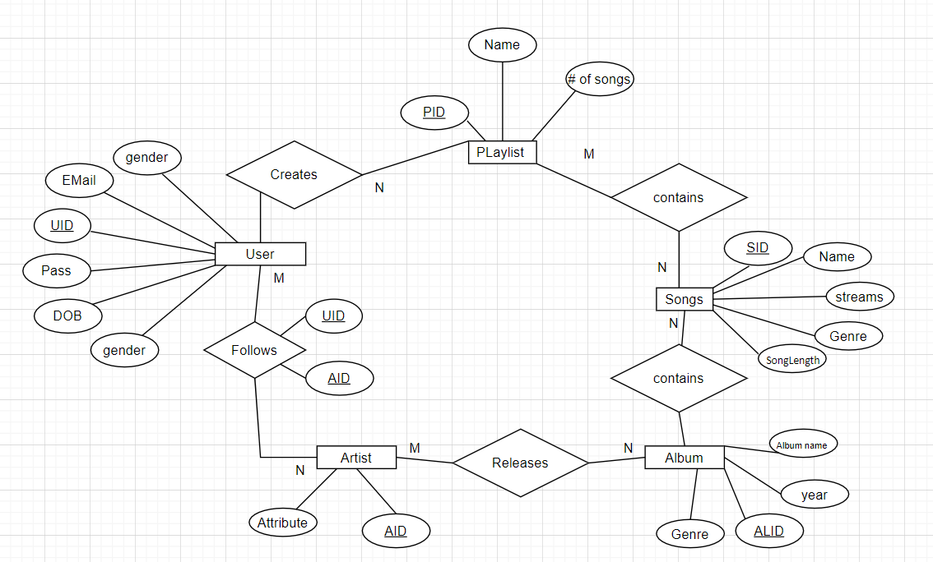

***TABLES:***

* User(UID, Email, UserPassword, Dob DATE, Gender, Subscription, CardNo)
* Artist : (AID , ArtistName)
* Album(ALID, AlbumName , AlbumYear , Genre)
* Songs (SID, AID , Streams , SongName, SongLength, Genre,ALID)
* Playlist ( UID , PID, PlaylistName,PL)
* Rel(ALID,AID)
* Follows(UID,AID,Followers,following )
* Contains (SID,PID)

User :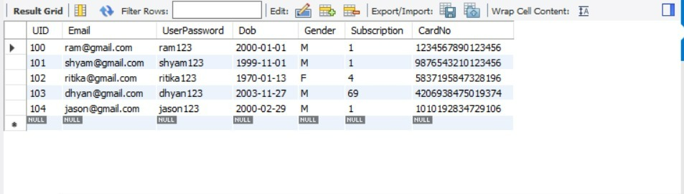

Artist : 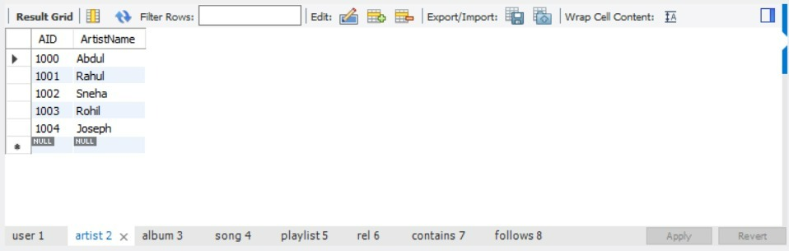

Album

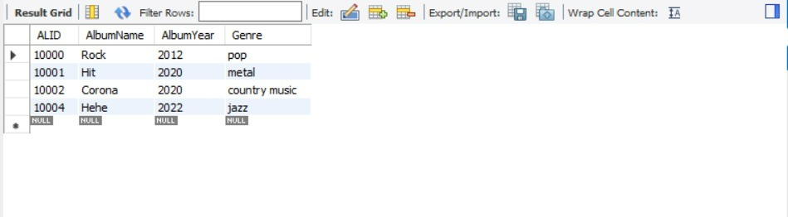

**Song**

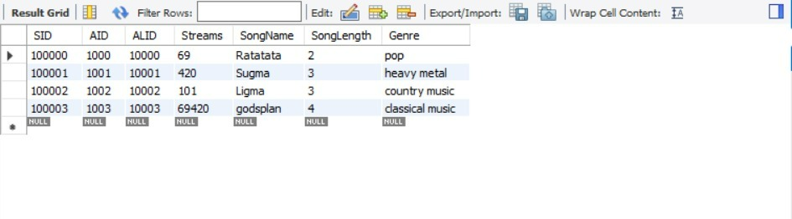

**Playlist**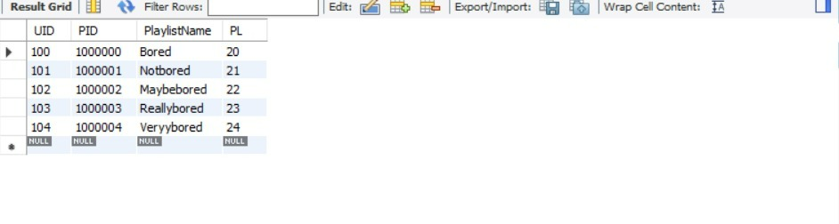

**Release**

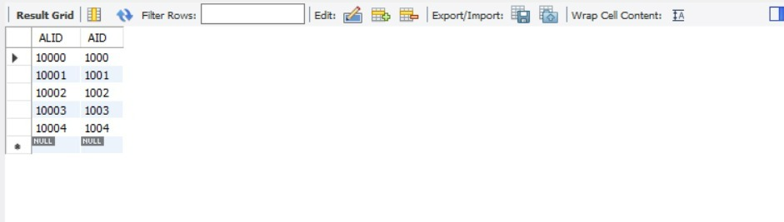

**Contains**

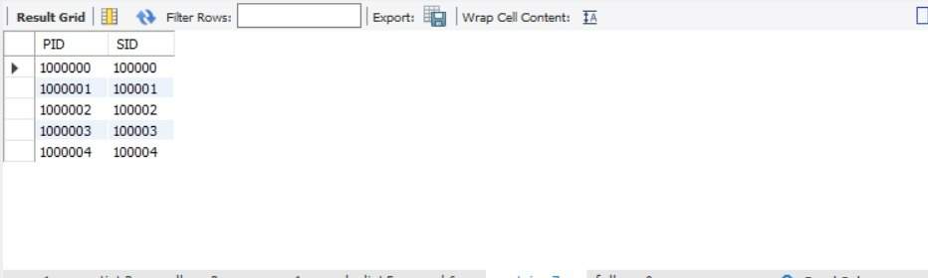

**Follows**

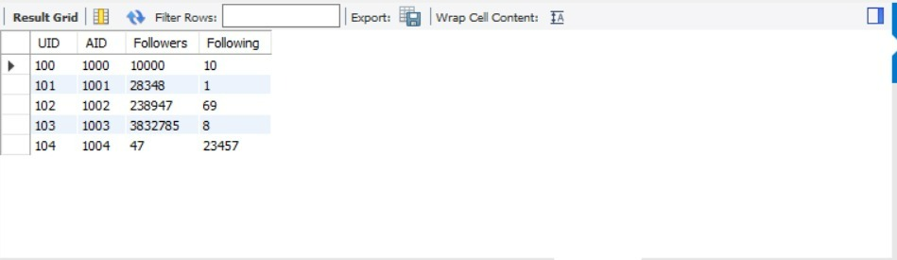

|  |  |
| --- | --- |
| **SN0** | **QUERIES** |
| 1 |  |
| 2 | give the maximum cost the blood |
| 3 | give details of all donars having blood group 0- or B- |
| 4 | increment the cost of all blood by 20% where cost is less than 1500 |
| 5 | which blood bank have bhavna as manager |
| 6 | list all the blood available at bank having manager Gaurav |
| 7 | give the detail of blood available at bank from where hospital 24hr homecare order |
| 8 | list all the donars with their blood grp having age more than prisha jain |
| 9 | give bank num of all the receptionst with first letter of their name as k |
| 10 | find all the blood present at blod bank where mahi donates the blood |
| 11 | give name and id of manager having 'a' at 3rd position |
| 12 | list blood group of donars who does not donates blood at bank 534 |
| 13 | give the bank detials where AB- AND O- are found |
| 14 | display blood details having 2nd least cost |
| 15 | create a view name donar_file which includes dname , gender , dage ,b_group,hospital name ,blood bank number |

**SELECT UID, Email, Dob, CardNo FROM user WHERE user.Subscription = 1;**

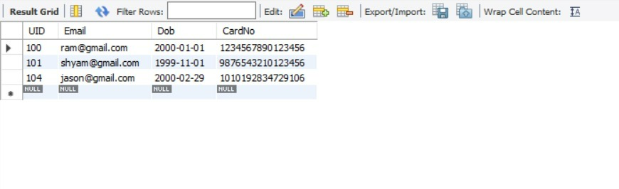

**SELECT AID, ArtistName FROM artist WHERE artist.ArtistName = 'Abdul';**

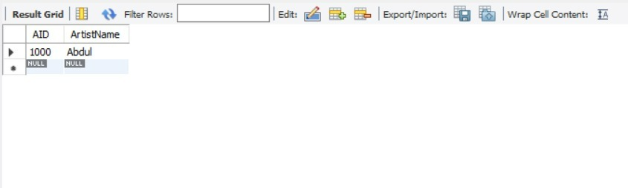

**SELECT AlID, AlbumName, AlbumYear, Genre FROM album WHERE album.AlbumYear = 2020;**

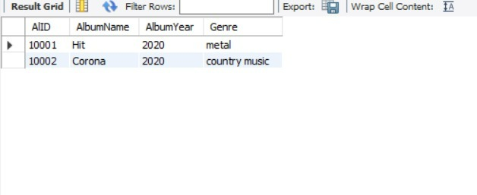

**SELECT SID, AID, ALID, Streams, SongName, SongLength, Genre FROM song WHERE song.Genre = 'pop';** 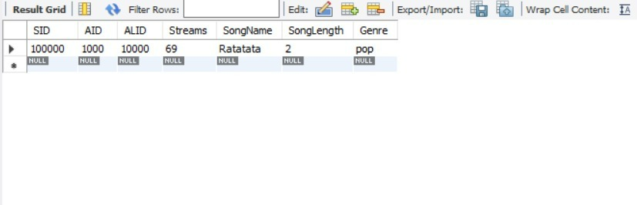

**SELECT UID, PID, PlaylistName FROM playlist WHERE playlist.UID = 102;**

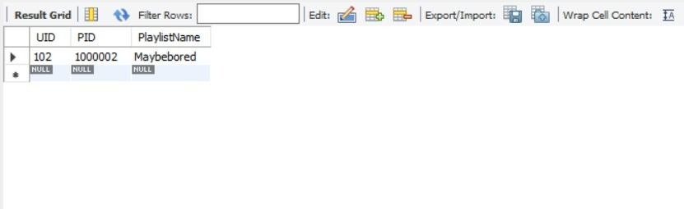

**SELECT DISTINCT genre FROM song;**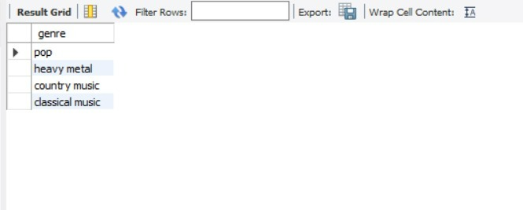

**SELECT Streams, AID FROM song ORDER BY Streams DESC;**

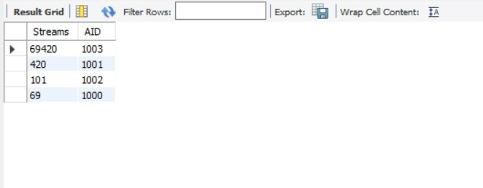

**SELECT UID, Email, Subscription FROM user ORDER BY CardNo DESC;**

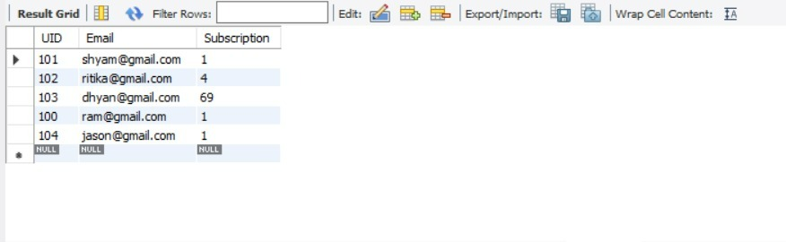

**SELECT ArtistName FROM artist WHERE EXISTS (SELECT Streams FROM song WHERE song.AID = artist.AID AND Streams > 1000);**

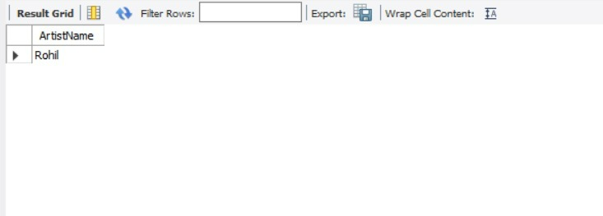

**SELECT AID, AVG(Streams) FROM song GROUP BY AID HAVING AVG(Streams) > 1000;**

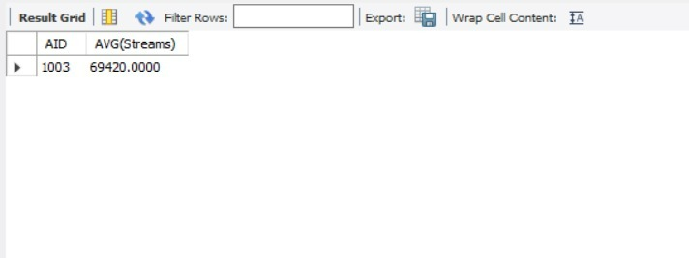

**SELECT s.* FROM song s, artist a WHERE a.AID = 1001 AND a.AID = s.AID AND s.SongLength < 200;**

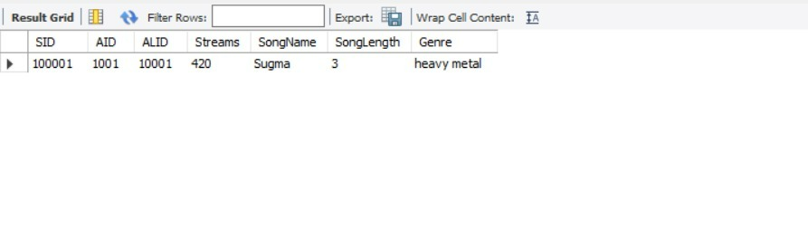

**SELECT COUNT(SID), AlID FROM song GROUP BY AlID ORDER BY COUNT(SID) DESC;**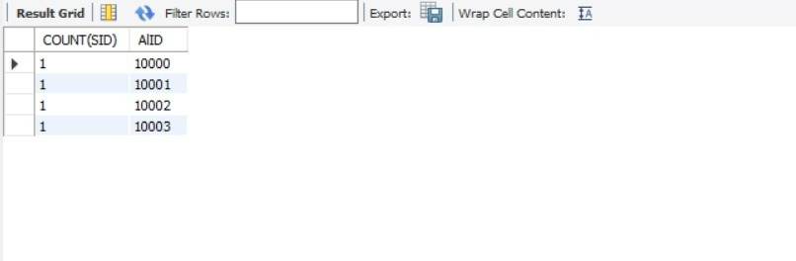

ALTER TABLE follows RENAME COLUMN followering TO following; 